Dis-**Peru-Chavin-Jaguar with Crenelated crown**

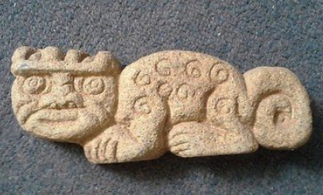

**Formal Label: Peru-Chavin-Jaguar with Crenelated crown**

**Accession Number:**

**LC Classification:** F3429.1.C48

**Date or Time Horizon:** **900 BCE–250 BCE**

**Geographical Area:** coastal Peru from Chan Chan to Pachacamac

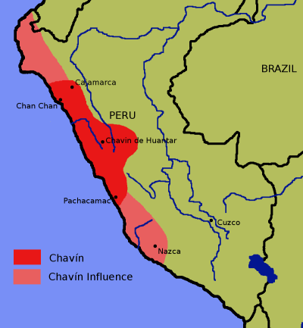

**Map**: Chavin culture extent. Created by [en:User:Zenyu](https://en.wikipedia.org/wiki/User:Zenyu) and released to {{PD}} by Zenyu, source.

**Cultural Affiliation:** Chavin

**Medium:** Granite

**Dimensions: L 6 in**  
**Weight:**

**Provenance:**

**Condition:** Museum quality

Discussion: The jaguar had a particular significance in many pre-Columbian cultures and most especially in the Chavin culture.

The Chavín developed their culture in the Mosna Valley at the confluence of the Mosna and Huachecsa near Chavin de Huantar at 3,150 m (10,330 ft) above sea level which encompasses three ecozones: the *quechua* (montane valleys), the *suni* (scrubs and agriculture), and the *puna* (mountaintop grassland) (Burger 2008; Pulgar 1979). In the Urabarriu period (900-500 BCE) the Chavin lived in dispersed settlements and depended on hunting and gathering as well as some primitive maize agriculture. During this period a jaguar cult developed that revered the powers of the feline mostly for hunting. Then, in one century (500-400 BCE), the dispersed settlements coalesced around the ceremonial center of Chavin de Huantar. Hunting diminished as the domestication of llamas and maize developed and trade expanded. The jaguar cult became less associated with hunting and more associated with a cult of élites.

Then, in the final stage of the Chavín culture, the Jarabarriu Period (400-250 BCE), a dramatic increase in population occurred simultaneously with vastly increased agriculture. During this period the jaguar cult became a cult of élites centered on a version of shamanism that revered the qualities of the jaguar. During this period the psychotropic San Pedro cactus may have been used. This cult of the jaguar was an idealization that became a means of acquiring power and of stratifying the society by the élites. Those who were accepted into the jaguar cult presumably represented the embodiment of extreme skill with an emphasis on defending the preservation and the expansion of territory. As the jaguar was seen as the perfect animal, in complete symbiosis with nature, and was able to capture virtually any other prey, the ideal warrior was seen to merge with the soul of the jaguar and to become one with him and set an example to the community. In the world-view of the Chavin of the Jarabarriu Period, the warrior was shamanically merged with the jaguar spirit, having assimilated its skill, strength, cunning, serenity, determination and precision.

This plaque of the revered jaguar is evidence of the last stage of the Chavin culture. During this period the development of asymmetrical power by the jaguar cult élites is reflected in the extensive remodeling of the Chavin d Huantar temple (Kembel and Rick 2004). Perhaps this granite jaguar was emplaced in one of these renovations as a symbol of the emerging rulers. With all this emphasis on the élite warrior cult, ironically, warfare does not seem to have been a significant factor in Chavín culture, since basic defensive structures in Chavín centers is missing, and Chavin art does not depict warriors except an élite class to which the jaguar plaque alludes.

**References:**

Burger, Richard L. 2008. "Chavin de Huantar and its Sphere of Influence", In *Handbook of South American Archeology*, edited by H. Silverman and W. Isbell. New York: Springer, pp. 681–706.

Burger, Richard L., and Nikolaas J. Van Der Merwe (1990). "Maize and the Origin of Highland Chavín Civilization: An Isotopic Perspective", *American Anthropologist* 92(1):85–95.

Pulgar Vidal, Javier. 1979. *Geografía del Perú; Las Ocho Regiones Naturales del Perú.* Edit. Universo S.A., Lima 1979.

Kembel, Silvia Rodriquez and John W. Rick. 2004. "Building Authority at Chavin de Huantar: Models of Social Organization and Development in the Initial Period and Early Horizon", in *Andean Archaeology*, Malden, Massachusetts: Blackwell Publishers.